ActiveTwo User Manual  Version:3.2  Date: July 3, 2007  BioSemi  WG-Plein 129  1054SC Amsterdam  Voice : +31 20 330 2957/2958  Fax : +31 20 330 2959  ABN-AMRO : 52.29.81.143  KvK Amsterdam : 33.267.855  VAT number : NL.8079.41.116.B.01 | 

Index: 1. General

1.1 About this manual
1.2 Markings on components
1.3 Certification
1.4 Intended purpose
1.5 System layout
1.6 Safe use
1.7 Specifications

2. System components

2.1 Active Electrodes
2.2 AD-box
2.3 Battery-box
2.4 Charger
2.5 Receiver

3. Maintenance

3.1 General maintenance
3.2 Electrodes handling

1.1 About this Manual

This manual describes the use and maintenance of the BioSemi ActiveTwo biopotential measurement system. Read this manual completely before putting the system into service. The following icons are used in this manual:

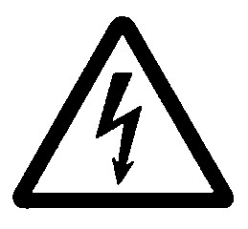 | Safety warning  Failure to follow these instructions may cause harm to subjects or operators.

 | Important note  Failure to follow these instructions may lead to unexpected operation or defects of the system.

 | Background information  This information does not immediately concern the basic use of the system, but is useful for understanding the designs philosophy and scientific opportunities offered by the system.

Additional information is available on the BioSemi website at www.biosemi.com. In many places inside this manual, there are links to additional comments on our website. The extra comments on our website are regularly updated according to user feedback, and may therefore cover extra information and user suggestions not yet available at the time of creating this manual.

For questions, please contact BioSemi at: Tel: +31 20 3302956
Fax: +31 20 3302959
Mobile: +31 650 626354
Email: info@biosemi.com

1.2 Markings on components

The following icons are used on ActiveTwo components:

 | Attention, consult accompanying documents (IEC 348)  This manual and the relevant sections on the BioSemi Website (see references in this manual) should be read before operating components showing this icon.

 | Type BF equipment (IEC 878-02-03)  Components showing this icon, are equipped with a Body Floating (BF) type Applied Part as defined in international standard EN60601-1, clause 2.2.25. For more information, see section 1.5 of this manual.

 | Conformité European  This mark is a declaration by the manufacturer that the respective component complies with the relevant directives and standards as issued by the European Union. For more information, see section 1.3 of these manual.

1.3 Certification

The ActiveTwo system bears the CE mark as a declaration of the manufacturer that the system meets the applicable standard for electromagnetic compatibility (EU directive 89/336/EEC) and electrical safety for the intended use as a biopotential measurement system in research applications. The following standards apply:

EMC compatibility: EN61326 (1997) + A1 (1998) + A2 (2001)
Electrical Safety: EN 60601-1 (1990) + A1 (1993) + A2 (1993) + A13 (1996)

A declaration of conformity is supplied with each ActiveTwo system
The conformity with the standards was examined by an external test house (D.A.R.E consultancy, Woerden, Netherlands, www.dare.nl). The test reports are available on request.

The CE mark on the ActiveTwo system is not equivalent with the medical CE mark found on Medical Devices (medical CE marks can be recognized by the identification number of the responsible Notified Body). Although the ActiveTwo system does comply with the demands for electrical safety used in the Medical Device directive, the system does not comply with several other requirements of the Medical Device directive 93/42/EEC.

1.4 Intended purpose

The BioSemi ActiveTwo measurement system is designed to measure potential differences on the human or animal body surface. The system is successfully used to record signals originating from the brain (electroencephalography, EEG), the hart (electrocardiography, ECG), and the muscles (electromyography, EMG) for research purposes. The ActiveTwo system can be adapted to these different applications by using different versions of the (active) electrodes. Besides body surface potentials, the ActiveTwo system can acquire signals from a wide range of additional sensors, in order to measure variables like body temperature, muscle force, etc.

The ActiveTwo is designed, and intended to be used as an instrument for scientific research only. The electrophysiological data acquired with the ActiveTwo is meant to be used within the framework of scientific research. The system is not intended for medical applications. The system is not approved and allowed to be used for diagnosis of diseases or treatment of disease, and the measured data shall not be used as a basis for any medical action. The system is not certified as a Medical Device as defined in EU directive 93/42/EEC, Article 1, Sec 2 (a) (European Union), or as defined in the Federal Food Drug & Cosmetic (FD&C) Act, Chapter II, Sec 201 (h) (USA).

The BioSemi ActiveTwo system is not designed to be used for diagnosis or treatment of disease. The intended use of the ActiveTwo is limited to scientific research. Using the ActiveTwo system as a tool for diagnosis or treatment may harm subjects

Because the ActiveTwo is designed as an instrument for research, it offers a flexibility that cannot be offered in a system designed for patient treatment. For example, the hardware configuration and the open-source software are highly configurable to adapt the system to various demands of different research applications. This flexibility, however, also allows the user to choose configurations and/or software modifications that lead to corrupted data being measured. This is the mains reason that the system shall not be used for diagnosis or treatment of patients. Moreover, the system is meant to be used only by skilled professionals.

1.5 System layout

The ActiveTwo system is based on the concept of optimal galvanic isolation between a front-end connected to the subject, and a back-end consisting of further signal processing hardware. For a diagram of the principle please see www.biosemi.com/pics/zero_ref1_big.gif.

Front-end: Section of the system consisting of Active Electrodes (2.1), AD-box (2.2) and Battery-box (2.3). The front-end is galvanically connected to the subject; the front-end is galvanically isolated from the environment (other equipment, mains power supply and safety earth).

Back-end: Section of the system consisting of Charger (2.4, Receiver (2.5), and Personal Computer with data-acquisition software (Part 2 of the manual). The back-end is galvanically isolated from the subject; the back-end is not galvanically isolated from the mains supply and the safety earth.

The ActiveTwo front-end is designed to digitize the signals from 8 up to 256 active electrodes and other sensors. The back-end processes the data: signals are displayed on a monitor and saved to hard disk, and optionally further processed online. The digitized data is transmitted from front-end to back-end via an optical fiber data link. The optical fiber (glasfiber core, plastic sheath, good isolator) is the only connection between the two sections of the system.

The setup of the ActiveTwo, with battery power supply of the front-ends, and fiber optic data transfer from front-end to computer, ensures the lowest possible capacitance of the isolation barrier between the isolated (floating) and non-isolated (connected to the safety earth) sections. The resulting isolation capacitance is magnitudes lower than can be achieved with alternative designs, based on optocouplers (data transfer) and DC-DC converters and/or isolation transformers (power supply). The isolation capacitance determines the amount of leakage current in both normal operation, and during several fault conditions. Minimal leakage current during normal operation is essential for the rejection of interference. Minimal leakage current in case of accidental contact between the subject and mains supply voltages is an important safety issue (http://www.biosemi.com/publications.htm).

The setup of the ActiveTwo system provides a BF (Body Floating) type isolation of the front-end, as defined in standard EN 60601-1. This feature is indicated by the appropriate symbol on the AD-box front-panel, please refer to section 1.3.

1.6 Safe use

The safe use of the ActiveTwo system is based on the galvanic isolation between the (battery powered) front-end, and (mains powered) back-end. During the use of the system, it is essential that this isolation barrier is not jeopardized by modifications, connection of additional equipment, or any other form of misuse.

Never short-circuit the galvanic isolation provided by the optical fiber connection
Do not connect any mains powered equipment to the front-end. Do not connect the front-end to the safety earth. Ensure that the subject cannot touch any part of the back-end: keep back-end at least 1.5 meters removed from the subject. Use only the original Battery-box as a power supply for the AD-box, do not attempt to use alternative power supplies.

Consult BioSemi before making additional connections to the AD-Box
For all additional signal sources interfacing with the ActiveTwo system, it is always necessary to assure that the additional connection does not compromise the isolation of the front-end. Therefore, all sensors connected to AD-box should be floating: they should be powered by the AD-box or extra dedicated battery power supply, and there should be no connection with any other (mains powered) equipment. Signals sources that are not isolated from the mains-supply, should interface with the trigger ports on the ActiveTwo receiver, or with the additional Analog Input Box (AIB).

Do not treat the skin to attempt reducing the electrode impedance
The active electrodes used in the ActiveTwo system ensure that high quality measurements are possible with high electrode impedances. Procedures such as scrubbing of the skin, as is required with conventional electrodes, can therefore be skipped. We strongly advise against skin scrubbing because it increases the danger of infections.

 | The electrical safety of the ActiveTwo system is based on the following principles:
 | -  -  -  -  -  - | Complete Front-end is Body Floating (BF type isolation)  Galvanic isolation between Front-end (electrodes, AD-box and battery), and back-end (receiver and PC). The Front-end is battery-powered, and the optical fiber for data transfer is the only connection between Front-end and Back-end. The Back-end is not located in the subject area (at least 1.5 meter away from the subject). No part of the Front-end should ever be connected to the Safety Earth, or to a mains powered system (battery connector design makes simultaneous connection to AD-box and charger impossible)  One-way communication front-end to Back-end  By single fiber connection, the data stream only conducts from the Front-end to PC. The Front-end runs independently from the PC, no sequential logic is implemented in the Front-end.  CMS/DRL circuit for subject grounding  DRL is the only low-impedance connection between the front-end (BF type applied part) and the subject, the current is limited by safety resistors (current via the subject limited to 40 uA under Single Fault Condition), all active electrode inputs have a high input resistance (> 1 GOhm) during normal operation.  Protection switch in power supply to active electrodes  The CMS/DRL circuit detects when the currents flow via the subject is out of the normal operation range (and always limits the current to 40 μA). In case of a problem, the operator is warned (blue indicator LED off), and the power-supply to all active electrodes is automatically switched off.  Guard circuit driving all accessible parts on front-end  All accessible conductive parts on the front-end are connected to a Guard circuit. The output current of the Guard circuit is limited by safety resistors (the patient auxiliary current is limited to less than 10 μA when subject touches any accessible part of the front-end).  Protection circuit senses voltage on accessible parts  The AD-box shuts down completely when the voltage on any accessible part is out of the normal operation range. This shutdown protects the subject for current flow when a defect AD-box would be touched. Examples of defects that will trigger the shutdown circuit are: loose power wire contacting the internal shield, and a short circuit between the shield and AD-box circuitry.

1.7 Specifications

Sample-rate options: (sample rate is adjustable by user) | 2048 Hz | 4096 Hz |  | 8192 Hz |  | 16,384 Hz
Max. number of channels @ selected sample rate: | 256 | 128 |  | 64 |  | 32
Bandwidth (-3dB): | DC - 400 Hz | DC - 800 Hz |  | DC - 1600 Hz |  | DC - 3200 Hz
Low-pass response | 5th order sinc digital filter
High-pass response | fully DC coupled
Digitalization: | 24 bit, 4th order Delta-Sigma modulator with 64x over sampling,  one converter per channel
Sampling skew: | < 10 ps
Absolute sample rate accuracy (over temp range: 0-70 C) | 0.1 Hz |  | 0.2 Hz |  | 0.4 Hz | 0.8 Hz
Relative sample rate accuracy (jitter) | < 200 ps
Quantization-resolution | LSB = 31.25 nV, guaranteed no missing codes
Gain accuracy: | 1 %
Anti aliasing filter | fixed first order analog filter, -3dB at 3.6 kHz
Total input noise (Z_{e} < 10 kOhm):, full bandwidth | 0.8 uV_{RMS}  (5 uV_{pk-pk}) |  | 1.0 uV_{RMS}  (6 uV_{pk-pk}) |  | 1.4 uV_{RMS}  (8 uV_{pk-pk}) | 2.0 uV_{RMS}  (12 uV_{pk-pk})
1/f noise (Z_{e} < 1 MOhm): | 1 uV_{pk-pk} @ 0.1..10Hz
Amplifier current noise: | < 30 fA_{rms}
Input bias current: | < 10 pA per channel
Input impedance Active Electrode | 300 MOhm @ 50 Hz (10¹² Ohm // 11 pF)
DC offset: | < 0.5 mV
DC drift | < 0.5 uV per degree Celsius
Input range | +262 mV to -262 mV
Distortion | < 0.1 %
Channel separation | > 100 dB
Common Mode Rejection Ratio | > 80 dB @ 50 Hz
Isolation Mode Rejection Ratio | > 160 dB @ 50 Hz
Power Consumption | 4 Watt @ 256 channels  inversely proportional with the number of installed channels
Battery capacity, standard battery | 25 Watt-hour, 3 cell sealed lead-acid  (double capacity battery is available as an option)
Battery life on standard battery | > 5 hours @ 256 channels  inversely proportional with the number of installed channels
Battery charge time (with external fast charger): | < 3.5 hours for a 100% charge
Leakage current, normal operation: | < 1 uA _{rms.}
Leakage current, single fault | < 50 uA_{rms}
Trigger inputs: | 16 inputs on optical receiver (isolated from subject section) , TTL level
Trigger outputs: | 15 outputs on optical receiver (isolated from subject section) , TTL level
PC interface: | USB2.0
Size of front-end, including battery-box (H x W x D) | 120 x 150 x 190 mm
Weight of front-end, including battery-box | 1.1 kg
Environment: | Indoor use: Temperature: +10°C to +40°C  Humidity: 30 to 75%  Pressure: 700 hPa to 1060 hPa
Warranty | 3 years (1 year on electrodes and batteries)

2.1 Active Electrodes

The active electrodes contain a Ag-AgCl sintered electrode pellet, and a buffer amplifier with an input protection circuit. The electrodes are sealed in a watertight resin. The electrodes can be used in connection with all commercially available electrode gels, but to achieve optimal results, we recommend the Parker Signa gel.
The integration of the first amplifier stage on the electrode, allows impedance transformation on the electrode (the active electrode has an output impedance lower than 1 Ohm). This makes it possible to measure body surface potentials with via high electrode impedances, without encountering the noise and interference problems seen in measurements with high-impedance passive electrodes, see:
http://www.biosemi.com/publications/pdf/Interference_reduction.pdf

With the active electrodes, procedures to reduce the impedance of the electrode-skin interface, such as scrubbing of the skin as is required with conventional electrodes, can therefore be skipped. This speeds up the application time considerably and makes the measurement procedure much more comfortable for the subject. We actually advise against scrubbing of the skin because is increases the danger of infections, see section 1.6 (safe use)

The CMS (Common Mode Sense) and DRL (Driven Right Leg) electrodes are used to drive the average potential of the patient as close as possible to the AD-box reference potential, see www.biosemi.com/pics/zero_ref1_big.gif. The CMS electrode is best located approximately in the center of the other electrodes (for example on the top of the head in case of a typical EEG measurement). In practice however, the exact location is not very critical though. The DRL electrode can be located anywhere on the body.
The DRL and CMS electrodes are part of o feedback loop. The feedback loop needs to be closed to be able to drive the subject to a potential close to the AD-box reference. If the loop is working properly, the Common Mode (CM) voltage (the average potential of the subject) is within the normal input range of the AD-box. This normal operation condition is indicated by the blue indicator LED (CM in range) being illuminated. The blue indicator can be found on the AD-box front-panel (see 2.2), and on the ActiView panel (see Part 2, software).

CM can only be in range by having both the DRL and CMS electrodes properly connected to the subject
As long as the loop is not closed, the blue indicator LED will remain off. In case of CM in range problems, always make sure to check first that the blue LED comes on with only the CMS and DRL electrode making contact with the subject (all other electrodes left unconnected)

The watertight sealing of the electrode circuitry and cable is essential for proper operation of the system. If the electronic circuitry of the electrodes is not completely sealed, (conductive) electrode gel and/or subject perspiration may creep into the circuit, and cause an internal short circuit. If the cable isolation is damaged, the bare core may touch the subject body. Finally, if one of the leads of an active electrode is interrupted (core breakage, connector problem, etc.) the input circuitry of the electrode is not properly biased. If any of these conditions occurs, leakage current will try to flow from defect electrode or cable, via the subject body, and via the DRL electrode back to the AD-box. The DRL drive circuit will limit this current to a safe value (40 μA), detect that the current flowing through the subject is out of the normal operation range, and the power-supply to all active electrode will be switched off automatically. This action of the protection circuitry is indicated by the blue indicator LED (CM in range) on the AD-box going off. As long as the blue indicator LED is not illuminated (Common Mode voltage is not in range), no valid measurements will be possible on any of the channels.

Valid measurement are only possible when CM is in range, (blue LED illuminated)
Any defect on electrodes, cables or connectors that forces the current via the subject to be out of the normal operation range causes the power to all active electrodes to be switched off automatically as a safety measure. The problem has to be corrected before the measurement can continue. Test the electrodes in salt water to find the defect, as explained in section 3.2

The active electrode are available in different versions, please refer to www.biosemi.com/active_electrode.htm for more details

Avoid contaminating connectors with electrode gel
Electrode gel is specially made to achieve good conductivity. Contaminating the connectors with gel may cause short circuits. Such a short will trigger the safety circuitry, and the blue indicator LED (CM in range) will remain off displaying an error. Clean the connectors as explained in section 3.2

2.2 AD-box

Front of the AD-box
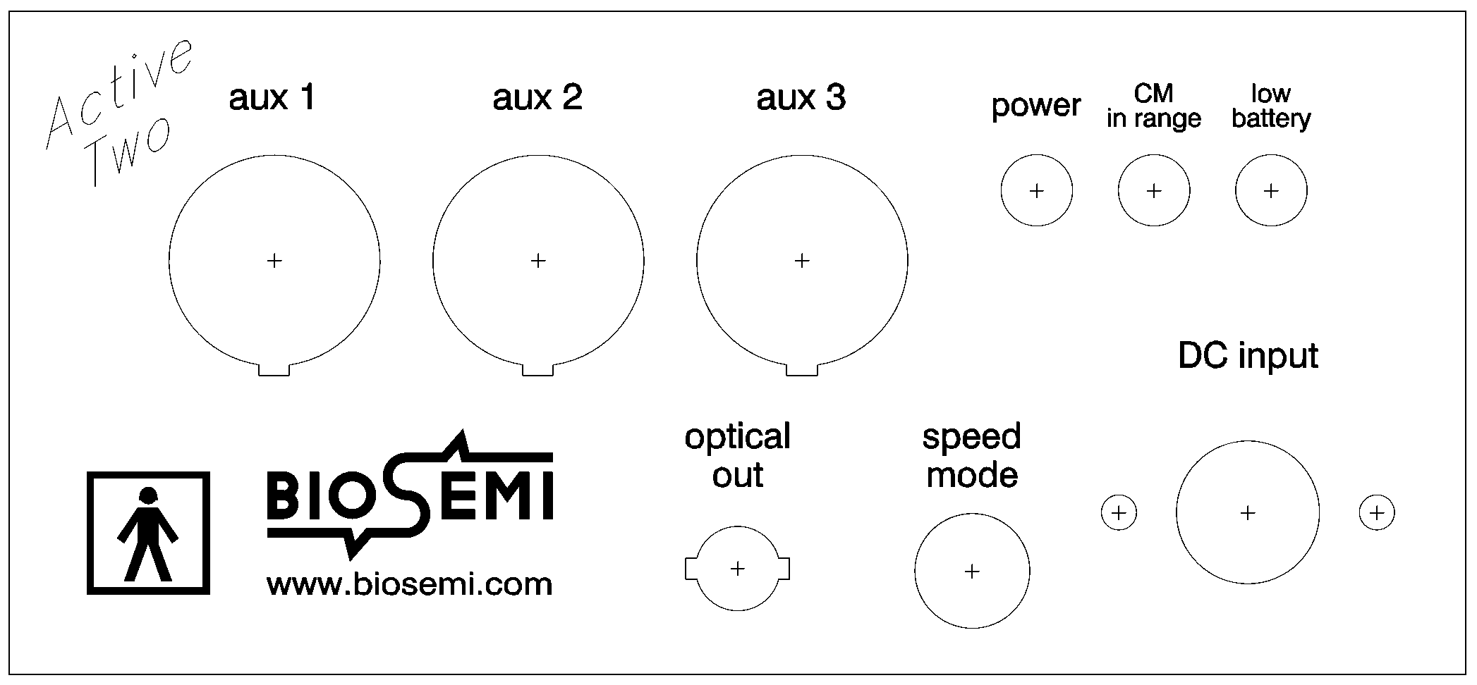

Aux1 - Aux3 | Input connectors for CMS/DRL electrode sets, and for additional sensors (Galvanic skin response (GSR), Ergo meter, Respiration, Plethysmograph, Temperature, or custom made sensors)
Power | Green indicator LED, illuminated when the power circuits of the AD-box operate correctly.
CM in range | Blue indicator LED, illuminated when the Common Mode voltage is within the normal operation range.
Low battery | Red indicator LED, illuminated when the battery voltage is running low
Optical out | Infrared LED data output, connect to the optical fiber going to the receiver/PC
Speed mode | Rotary switch to select the sampling rate of the AD-box. (see table below)
DC input | Input connector for the power cable form the Battery-box (6 VDC)

Top of the AD-box
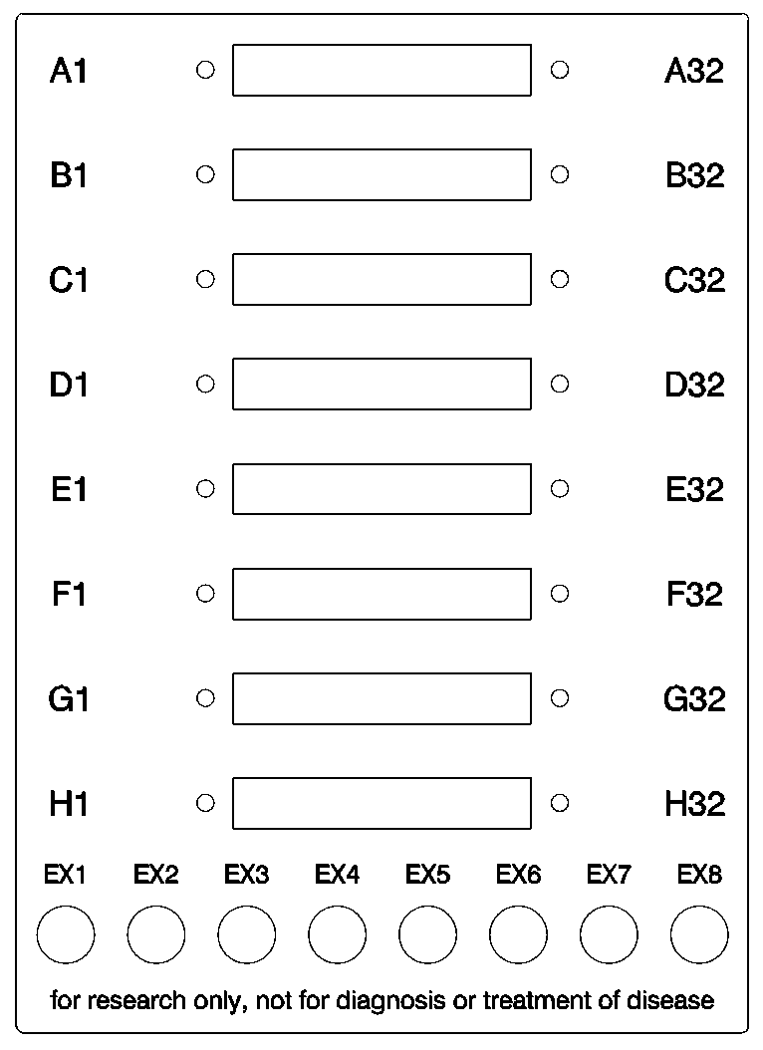
  A1-A32 | Input for channels 1 to 32 plus CMS/DRL
  B1-B32 | Input for channels 33 to 64
  C1-C32 | Input for channels 65 to 96
  D1-D32 | Input for channels 97 to 128
  E1-D32 | Input for channels 129 to 130
  F1-F32 | Input for channels 131 to 192
  G1-G32 | Input for channels 193 to 224
  H1-H32 | Input for channels 225 to 256
  EX1 | TouchProof input EX1 (channel 233)
  EX2 | TouchProof input EX2 (channel 234)
  EX3 | TouchProof input EX3 (channel 235)
  EX4 | TouchProof input EX4 (channel 236)
  EX5 | TouchProof input EX5 (channel 237)
  EX6 | TouchProof input EX6 (channel 238)
  EX7 | TouchProof input EX7 (channel 239)
  EX8 | TouchProof input EX8 (channel 240)

The electrode signals are amplified and converted from analog to digital format in the AD-box. The amplifier/converter circuits are integrated on 8 channel modules, the AD-box can be equipped with up to 32 of these modules. This allows the AD-box to be configured for operation with 8 to 256 channels (in steps of 8). All digital data is multiplexed into a serial data stream, and sent to the signal processing PC via an optical fiber.

Under normal operation, the green LED is on (showing that the power-supply circuitry operating properly), the blue LED is on (Common Mode in range, CMS and DRL electrodes properly connected, no defective electrodes or cables), and the red LED is off (battery sufficiently charged). When the battery voltage is running low, the red indicator LED will illuminate. At that time, there is 30-60 minutes operational time left (depending on the number of installed channels), before the shut-down circuitry in the Battery box will disconnect the AD-box from the battery power supply.

Signal quality is not affected when “low battery” is indicated
The shutdown circuitry in the Battery-box operates at a voltage where there is still sufficient power available for the circuitry in the AD-box. As long as the shutdown is not triggered, the data quality is assured. The “low battery” warning is given 30-60 minutes prior to the moment of shutdown.

The AD-box power circuits shut down when the voltage of the accessible metal parts is not within the normal operating range
This is a safety feature to detect a loose wire inside the box touching the box shield. The safety circuit can be reset by switching the power off and on again. If this does not solve the problem, stop the experiment, and return the AD-box to BioSemi (or its local representative) for repair.

The condition of all (3) indicator LEDs blinking, indicates a short circuit inside the AD-box
Switch off the power, and disconnect the electrodes. Return the AD-box to BioSemi (or its local representative) for repair. There is no immediate danger for the subject because of the CNS/DRL and Guard circuit safety resistors, and because the power to the active electrodes is shut off.

Speed-mode settings

First identify if your AD-box is a Mk1 or a Mk2. This is done by running ActiView and then looking at the ‘About ActiView’ tab-page. There it is shown if your AD-box is a Mk1 or a Mk2.

SpeedMode | Sample-rate | AD-box Mk1 |  | AD-box Mk2
 |  | PIN + TP ch. | Sensors | PIN + TP ch. | Sensors
0 | 2048 (2 kHz) | 256 + 0 | No | Multi box use:  In speedmode 0-3, the AD boxes work as up to 4 optical fiber ‘daisy chained’ boxes, each with a maximum of 128+8 channels @ 2kHz. The speedmode switch = box number. (0=Box1, 1=Box2, 2=Box3, 3=Box4). Daisy chain possibilities are not included in the standard base system.
1 | 4096 (4 kHz) | 128 + 0 | No
2 | 8192 (8 kHz) | 64 + 0 | No
3 | 16384 (16 kHz) | 32 + 0 | No
4 | 2048 (2 kHz) | 232 + 8 | Yes | 256+8 | Yes
5 | 4096 (4 kHz) | 104 + 8 | Yes | 128+8 | Yes
6 | 8192 (8 kHz) | 40 + 8 | Yes | 64+8 | Yes
7 | 16384 (16 kHz) | 8 + 8 | Yes | 32+8 | Yes
8 | AIB-mode | AIB-mode | AIB-mode | AIB-mode | Yes
9 | Reserved | Reserved | Reserved | Reserved | Reserved

Note: When an AIB is connected, the AD-box should always be on SpeedMode 4.

The rotary switch can be used to select 8 different speedmodes for the AD-box (speed-mode 9 is reserved for use as Analog Input Box). Use a small screwdriver to rotate the switch to the preferred number according to the table above.

After changing the speed-mode, switch the AD-box off and on again to reset the ADCs
Changing the speed-mode having the power connected is not harmful to the electronic circuitry, but the synchronization between channels may be lost.

The acquisition software adjusts automatically to the selected speed-mode (check the indicator in the “about ActiView” tab page). It is recommended to restart the ActiView software completely after changing the speedmode, to prevent selectors from remaining disabled in the new speed-mode. For more information, please refer to Part 2 of the manual (software)

2.3 Battery-box

Front of the Battery-box
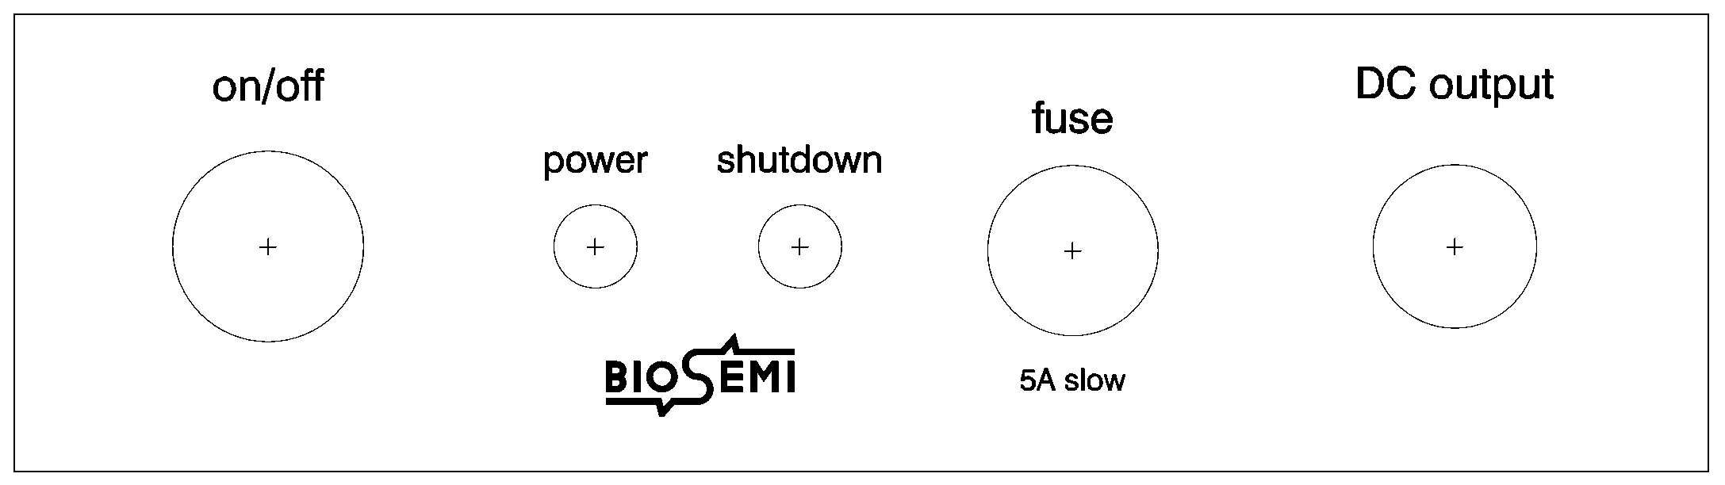

On/off | Master power switch. Use this switch to switch the connected AD-box ON and OFF. A green “fisheye” indicates the switch position.
Power | Green indicator LED, illuminated when the power supply voltage is available at the DC output, unless the shutdown indicator LED is also illuminated.
Shutdown | Red indicator LED, illuminated when the internal protection circuit has disconnected the DC-output form the battery.
Fuse | Main fuse to protect the battery for short circuits (5 Ampere, slow blow)
DC output | Cable and connector for connection to the AD-box, or to the Charger

The Battery-box contains a sealed lead-acid battery (6 Volt) and a shut-down circuit. The shutdown circuit protects the battery for deep discharge, which would shorten the battery life. When the battery voltage is running low, there will first be a warning on the AD-box front panel (red indicator LED illuminated) and on the ActiView software panel on the computer screen (pop-up window, and illuminated red indicator light). At this moment, there is 30-60 minutes operational time left (depending on the number of installed channels). After that time, the shut-down circuit in the Battery-box will disconnect the AD-box from the battery.

The shutdown circuit may be triggered by connecting the Battery-box to the AD-box with the power switched ON
Switch the power OFF, and ON again to reset the shutdown circuitry.

Replace the fuse when the green indicator LED (power) does not illuminate with the power switched on (fisheye inside the button shows green)
Use a 5 Amp slow blow type. If the problem persists, the Battery-box should be returned to BioSemi (or its local representative) for repair.

The batteries can be recharged irrespective of the state of charge (there is no memory effect). The service life of the batteries is decreased if they are left for long periods of time in a state of low charge. Therefore: recharge the batteries soon after the shut-down circuit has been triggered (within a day or so), charge the batteries fully before prolonged storing, and recharge stored batteries every 6 months. The batteries are rated for approx. 1000 full charge-discharge cycles. When the capacity of the battery starts to decrease (both charge and discharge times decrease), the battery is approaching the end of its service life; please return the Battery-box to BioSemi (or its local representative) for replacement of the cells.

Use only the Charger type as originally provided with the ActiveTwo system
The provided Charger is designed to deliver the correct charging voltage and current for the batteries. Using any other charging method may damage the battery, or even result in a dangerous situation.

The setting of the power switch on the Battery-box makes no difference during charging
The power switch is by-passed during charging, it is not necessary to switch the Battery-box to the position ON during charging.

After the useful service live, return the Battery-box to BioSemi (or its local representative) for replacement of the cells
Alternatively, use a disposal method according to the regulations in your territory for lead/acid batteries. Never dispose of the batteries as normal household waste. Do not attempt to disassemble the Battery-box, or to open sealed lead/acid cells.

2.4 Charger

Charger
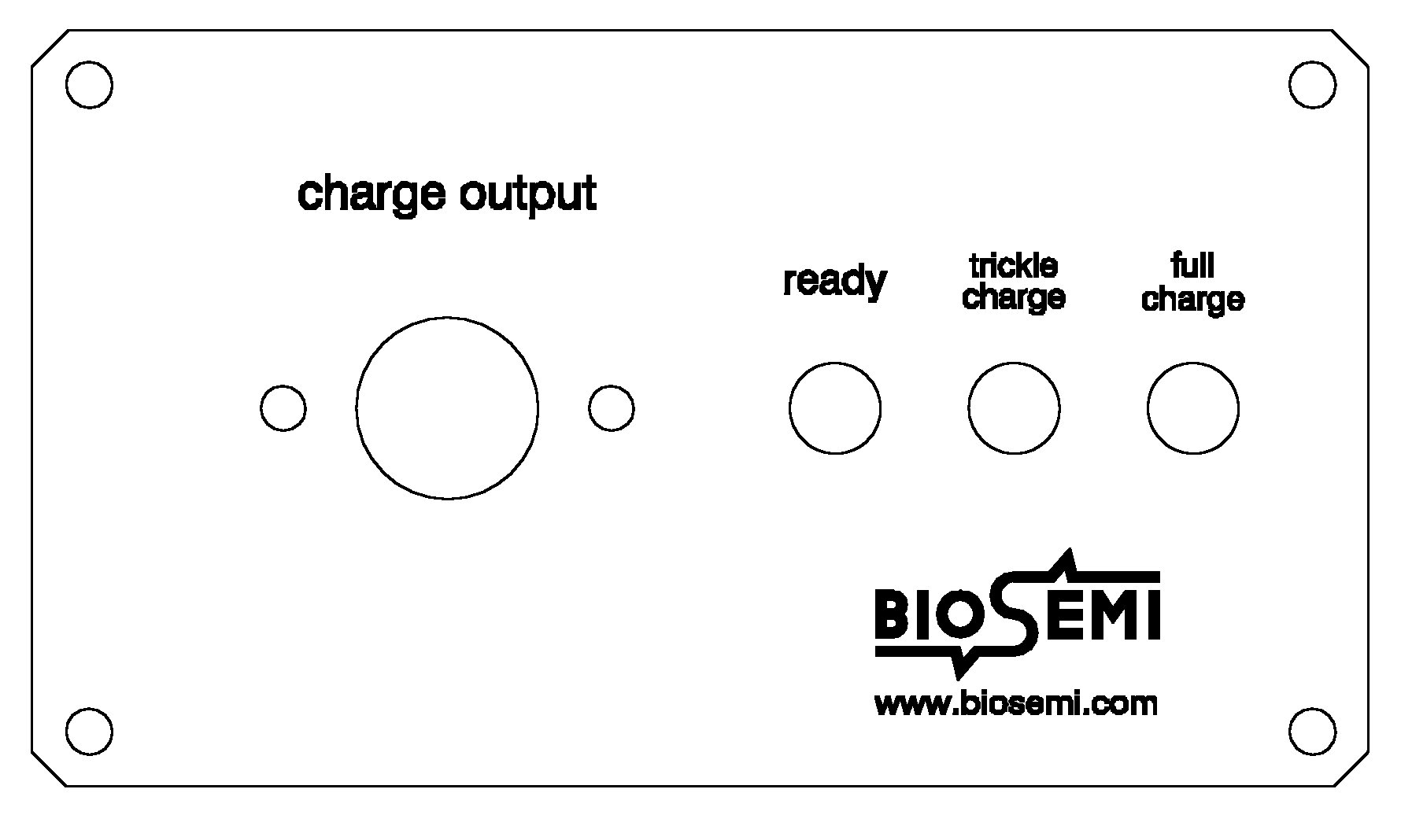 | 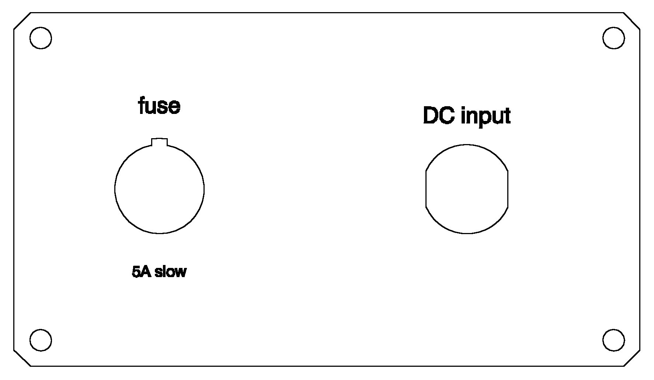

Charge output | Connector for the Battery-box.
Ready | Green indicator LED. Indicates “power on” when no Battery box is connected. Indicates that a connected Battery-box is fully charged.
Trickle charge | Yellow indicator LED, illuminated when a connected Battery-box is 90% charged.
Full charge | Red indicator LED, illuminated when a connected Battery box is being charged on full current.
Fuse | Main fuse (5 Ampere slow blow)
DC input | Connector (2mm type) for the supplied mains adapter.

The charger is capable to fully charge a battery within 3 to 4 hours. During the charge cycle, the indicator LEDs will go from “full charge” to “trickle charge”, and finally to “ready”. The red LED indicates that the battery is being charged, this LED will come on when a battery is connected that is not fully charged (anything between 90% and 0% charge). The yellow LED indicates that the battery is 90% charged. The last 10% may take relatively long: approx. 1 hour at the most. The battery can be re-used when the yellow LED comes on, but it is recommended to charge the battery fully (until the green LED comes on) once in a while.

The Charger switches to stand-by current when the green indicator LED comes on. The Battery-box can be left connected to the Charger for indefinite periods of time; there is no danger for over-charging. Leaving the Batteries-box connected to the Charger on stand-by current for long periods of time (days) ounce in a while, actually helps to prolong battery life. Typically, one of the two Battery-boxes provided with the ActiveTwo system would be connected to the Charger, where the other one would be in use as power supply for the AD-box. The batteries would then be swapped at the time a low remaining power capacity for the battery in use is indicated by the “low battery” indicator LED on the AD-box.

Use only the wall adapter as provided with the ActiveTwo system
The Charger is designed to only work in combination with the supplied mains adapter (Friwo FW7301/09). Using any other power-supply for the Charger, or may lead to damage of the Charger, and/or a connected Battery-box, or may even result in a dangerous situation

Leave the Charger connected to the power-supply when a Battery-box is connected
When the Charger is OFF, the battery will slowly discharge via the Charger’s internal circuitry. As long as a Battery-box is connected, do not disconnect the Charger from the mains adapter, and do not unplug the mains adapter from the wall socket.

An abnormally long charging time would indicate a defective Battery-box
When full charging (red indicator LED) prolongs beyond approx. 6 hours, and/or the Battery box becomes warm during charging, the charging process is not proceeding normally. The typical cause is a defective Battery-box. Disconnect the Battery-box from the charger, and return to BioSemi (or its local representative) for inspection.

The provided mains adapter is a world-wide version.
The mains adapter can be used with mains voltages between 100 and 240 Volt, with a frequency between 47 and 63 Hz. This makes the mains adapter suitable for mains supplies in virtually any country in the world. Different mains plugs can be fitted to the adapter to comply to various types of connector world-wide used.

2.5 Receiver

USB Receiver
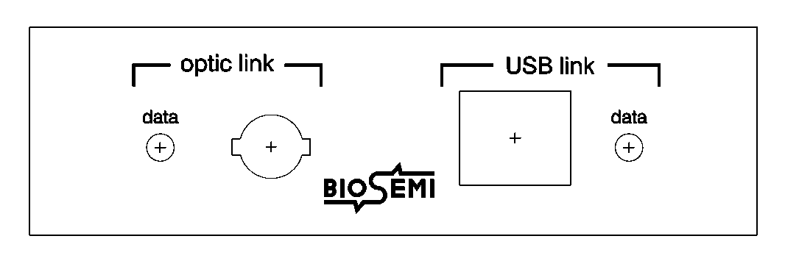 | 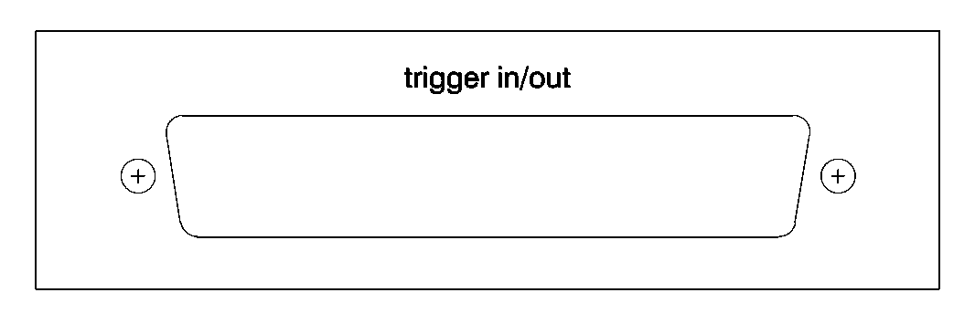

Optic data | Green indicator LED, illuminated when optical data is received from the AD-box.
Optic link | Connector for the optical fiber coming form the AD-box (ST type connector).
USB link | Connector for the standard USB cable to the USB2.0 port on the Personal Computer
USB data | Green indicator LED, illuminated when data is being transferred form the receiver to the Personal Computer.
Trigger in/out | Input/output port for synchronizing stimuli and responses with the AD-box data. 37 pins Sub-D connector with 16 inputs lines and 15 output lines (TTL level).

The receiver converts the optical data stream form the AD-box into an USB2 compatible signal to the PC. In addition, trigger input signals are added to the data stream see http://www.biosemi.com/faq/trigger_signals.htm. In addition, the receiver can sent output pulses via the trigger port. Finally, the sample-rate frequency is available at the trigger port for synchronization purposes.

Layout of the Trigger input/output connector on the USB receiver.
Pin01 = Trigger input 1 | Pin11 = Trigger input 11 | Pin21 = Trigger output 5 | Pin31 = Trigger output 15
Pin02 = Trigger input 2 | Pin12 = Trigger input 12 | Pin22 = Trigger output 6 | Pin32 = Sampling frequency
Pin03 = Trigger input 3 | Pin13 = Trigger input 13 | Pin23 = Trigger output 7 | Pin33 = n.a.
Pin04 = Trigger input 4 | Pin14 = Trigger input 14 | Pin24 = Trigger output 8 | Pin34 = n.a.
Pin05 = Trigger input 5 | Pin15 = Trigger input 15 | Pin25 = Trigger output 9 | Pin35 = n.a.
Pin06 = Trigger input 6 | Pin16 = Trigger input 16 | Pin26 = Trigger output 10 | Pin36 = n.a.
Pin07 = Trigger input 7 | Pin17 = Trigger output 1 | Pin27 = Trigger output 11 | Pin37 = Ground
Pin08 = Trigger input 8 | Pin18 = Trigger output 2 | Pin28 = Trigger output 12
Pin09 = Trigger input 9 | Pin19 = Trigger output 3 | Pin29 = Trigger output 13
Pin10 = Trigger input 10 | Pin20 = Trigger output 4 | Pin30 = Trigger output 14

The receiver is powered from the PC power supply via the USB connecting cable. With the receiver connected to the PC, the optic data LED indicates whether data is received from the AD-box. In case the data LED remains off, check the fiber connection and AD-box power indicator.

The USB data LED illuminates when the USB handshake between receiver and USB is established. The handshake is operational during data acquisition with the ActiView software (press the “start” control, see Part 2 of the manual: software). In case the USB data LED remains off, check the installation of the USB device drivers (Part 2 of the manual), and check that the USB port on the PC meets the USB version 2.0 specification (USB1 is too slow to handle the ActiveTwo data throughput, the handshake will not be established).

The receiver connects to both desktop and laptop computers.
The USB port should meet the 2.0 specification, operating system should be Windows XP (the provided USB drivers work only under XP), the processor should be a Pentium IV running at a minimum of 1 GHz (> 2 GHz is recommended), and the screen resolution should be at least 1280*1024 (1600*1200 is recommended).

3.1 General Maintenance

The ActiveTwo system contains no user-serviceable components.

Unauthorized repairs or modifications to the Front-end components may cause a safety hazard.
Always return malfunctioning Front-end components to BioSemi (or its local representative) for inspection and/or repair.

Clean the system components with a slightly damp soft cloth,
It is permitted to use a mild soap solution if necessary, nut never use aggressive or abrasive cleaners or solvents. Use any cleaning fluid sparingly. Prevent any fluid from entering the connectors or enclosures, and let the devices dry completely before putting the same into service again.

It is not necessary to adjust or calibrate the system during its normal service life (10 years).

3.2 Electrode handling

Five Rules of thumb:
1) Do not kink the electrode wires. Especially where the wire exits the electrode housing.
2) Clean electrodes softly immediately after use (when the gel is still soft) by hand with warm water.
3) Do not use aggressive soaps etc, do not let the pellets touch any kind of metals.
4) Do not pull-out the electrodes at the flat cable (grab the electrodes at the casing)
5) Do not let water or gel enter the connector.

Handling
Do not bend the wires at the place where the wire exits the electrode housing.
Do not pull-out the electrodes at the flat cable. Grab the electrodes at the casing, and then pull them softly out of the headcap. Do not grab the electrode housing at the place where the wire exits the housing, this will bend the wires, resulting in kinked wires sooner. The AD-box has ejectors on the top for easy removal of the connector. Always make sure to use them. Keep the connector clear of water/gel. When a connector is polluted with gel or salt water, it should be rinsed with distilled water, followed by a rinse with alcohol (ethanol).
After applying the electrodes, it takes some time before the chemical reactions in the electrode-gel-skin interface have reaches a stable equilibrium. After approx. 5 minutes baseline drift and noise will have settled to a low figure.
Soaking the electrodes in water is generally not recommended because of corrosion danger. Should you still want to do this, limit it to 15 minutes.
Cleaning
An excessive cleaning process will wear and tear your electrodes more quickly. Bending the wires to much during the cleaning process will result in kinked wires to show up sooner. So, clean the electrodes gently after use and then let them hang to dry. Use warm tap water to rinse off the gel from the electrodes (make sure to keep the connector dry). Warm water (up to 50 degrees Celsius) will dissolve the gel quickly. Only use a soft brush for removing gel residues from the electrodes if absolutely necessary. Softly dry the electrodes with hand paper. Let them hang out to dry on the cable-rack which was supplied together with your BioSemi system. Only use soap if water does not seem to clean the electrodes properly, never use solvents (e.g. acetone), acids or alkaline. Do not let the electrodes dry without being cleaned first. When the electrodes dry up covered with gel/salt/minerals, the cleaning process will be harder and you will get kinked wires sooner due to this hard/extensive cleaning process.
Disinfection is generally not necessary because active electrodes work without skin scrubbing. In the case that disinfection is inevitable, use only alcohol. The active electrodes are tested for compatibility with alcohol. Other disinfection agents (Metricide, Sekusept) are know to cause corrosion of the AgAgCl electrode tips, which can cause broken electrode tips when used frequently.
The silver/silver-chloride (AgAgCl) sintered electrodes behave like sponges, they absorb water and electrode gel. The deeper the water/gel has penetrated the electrode, the longer it will take afterwards for the water to vaporize. As long as your electrodes are ‘wet’, corrosion processes will take place. This corrosion process will in the very long run make your electrodes noisier.
Storage/Modifications/Splitting of the flat cable
Do not store the electrodes in a metal box. In general, prevent the electrode tips from touching any metal objects, because this causes pollution of the Ag/AgCl pellets with “strange” metal particles (increasing noise). Exposure of the AgAgCl electrode tip to light also causes deterioration. Best storage method is use the cable-rack which was supplied together with your BioSemi system and hang them in a dark place. The electrodes are not intended to be modified by the customer. Especially "splitting" the flat-cable further may lead to a non-repairable malfunction and void your warranty!
Malfunctions
If an electrode is not operating as specified, please do the following:
Soak the electrodes in water with some salt added (one small teaspoon, use a non-metal bowl)
- If this causes the blue led to turn off, then the electrode set is in need of repair (return to dealer/manufacturer)
- If you experience noise, then please follow-up the directions below concerning noisy electrodes.
Noisy electrodes: (also read “Life span”)
Noisy electrodes generally mean that your electrodes have reached its end of life. You can extend the life a little bit by placing the electrodes in salt water for about an hour before you start your measurement. This soaking process often removes noise. A last remedy is to use a grain 600 or higher waterproof abrasive paper to polish the electrode tip. Use very soft circular movements, preferably no more than 2-3 times on the same area, removing an even very thin layer across the entire surface of the tip.

Life span (Life expectancy)
Ag-AgCl sintered electrodes have a limited life span. This is caused by several processes such as corrosion, the dissolving of the Chloride in the pellets and the wearing of the pellet during the cleaning process. After approximately 200 measurements, low frequency noise will slowly increase. This is seen as baseline drift and higher offset values. Also, mechanical problems such as broken/kinked wires are inevitable after approximately 200 measurements.
If the salt water test displays increased noise and unstable offset values, it’s time to replace the electrodes.

